1. Create a navigation bar using HTML and CSS. Implement a hover effect on the navigation items so that the background or text color changes when the user hovers over each menu item.

**Task#1:**

* **Index.html**

|  |
| --- |
| **<!DOCTYPE html>**  **<html lang="en">**  **<head>**  **<meta charset="UTF-8">**  **<meta name="viewport" content="width=device-width, initial-scale=1.0">**  **<title>Navigation Bar</title>**  **<style>**  **body {**  **font-family: Arial, sans-serif;**  **margin: 0;**  **padding: 0;**  **}**  **.navbar {**  **display: flex;**  **background-color: #0f017d;**  **padding: 10px;**  **}**  **.navbar a {**  **color: white;**  **text-decoration: none;**  **padding: 10px 20px;**  **transition: background-color 0.3s, color 0.3s;**  **}**  **.navbar a:hover {**  **background-color: #000000;**  **color: #a438af;**  **}**  **</style>**  **</head>**  **<body>**  **<div class="navbar">**  **<a href="home.html">Home</a>**  **<a href="about.html">About</a>**  **<a href="services.html">Services</a>**  **<a href="contact.html">Contact</a>**  **</div>**  **</body>**  **</html>** |

**Output:**

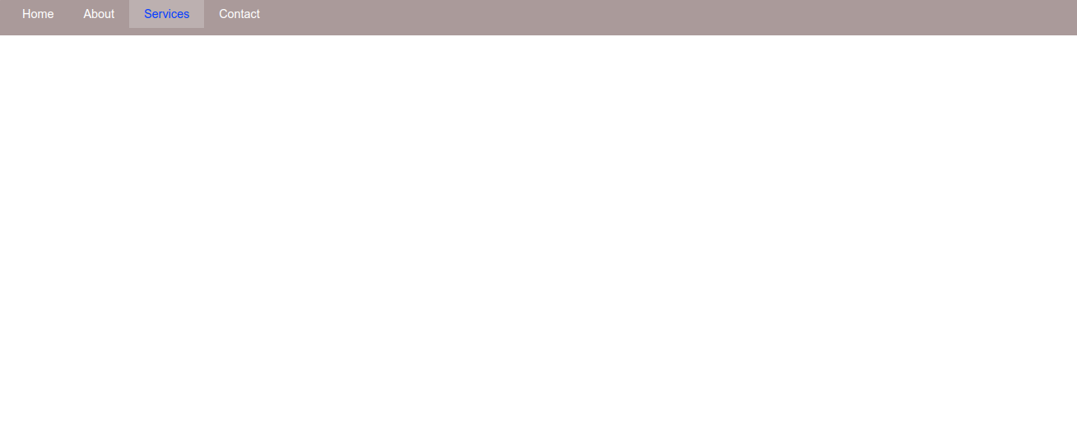

2.. Create three <div> elements on a webpage. Apply a **transition effect** so that when the user hovers over each <div>, the color or size changes smoothly.

**Task#2:**

* **Index.html**

|  |
| --- |
| **<!DOCTYPE html>**  **<html lang="en">**  **<head>**  **<meta charset="UTF-8">**  **<meta name="viewport" content="width=device-width, initial-scale=1.0">**  **<title>TRANSITION SHOW:</title>**  **<style>**  **.box {**  **width: 100px;**  **height: 100px;**  **margin: 20px;**  **display: inline-block;**  **border-radius: 20px;**  **border-top-left-radius: 20px;**  **border-top-right-radius: 10px;**  **border-bottom-left-radius: 30px;**  **border-bottom-right-radius: 8px;**  **background-color: rgb(230, 173, 217);**  **transition: all 0.3s ease;**  **}**    **.box:hover {**  **background-color: rgb(115, 255, 80);**  **transform: scale(1.2);**  **}**  **</style>**  **</head>**  **<body>**  **<div class="box"></div>**  **<div class="box"></div>**  **<div class="box"></div>**  **</body>**  **</html>** |

**Output:**



3.Create three <div> elements on a webpage. Apply a **CSS animation** to each of them that activates when the user hovers over the divs. The animation will rotate the <div> and change its background color

* **Index.html**

|  |
| --- |
| <!**DOCTYPE html>**  **<html lang="en">**  **<head>**  **<meta charset="UTF-8">**  **<meta name="viewport" content="width=device-width, initial-scale=1.0">**  **<title>TRANSITION SHOW:</title>**  **<style>**  **.box {**  **width: 100px;**  **height: 100px;**  **margin: 20px;**  **display: inline-block;**  **border-radius: 20px;**  **background-color: rgb(230, 173, 217);**  **transition: all 0.3s ease;**  **}**  **.box:hover {**  **animation: rotateAndChangeColor 0.5s ease forwards;**  **}**    **@keyframes rotateAndChangeColor {**  **0% {**  **transform: rotate(0deg);**  **background-color: rgb(230, 173, 217);**  **}**  **100% {**  **transform: rotate(360deg);**  **background-color: rgb(115, 255, 80);**  **}**  **}**  **</style>**  **</head>**  **<body>**  **<div class="box"></div>**  **<div class="box"></div>**  **<div class="box"></div>**  **</body>**  **</html>** |

**Output:**

